# 1 Introduction

Cancer arises from the transformation of normal cells into tumour cells in a multi-stage process that generally progresses from a pre-cancerous lesion to a malignant tumour [1]

The advancement in molecular biology over last 20 years have sparked hope in cancer treatment and resulted in slew of targeted medications on the market. In the vast majority of solid tumors, however, curative therapy of cancer is still attainable with only early diagnosis and early management. Almost half of cancer patients diagnosed each year throughout the world die of the disease. Patients with distant metastases, in particular, have no hope of being cured with existing therapeutic options.

Over this last 20 years, monoclonal antibody based cancer treatment has proven to be one of the most effective therapeutic options for both hematologic and solid cancers.

# 

# 2 Cancer

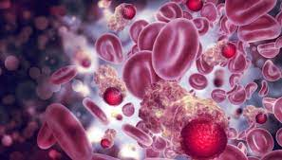

Figure 1 Cancer Cells [2]

Cancer is a major global health issue that claims the lives of more than eight million people each year. It is a multifaceted disease involving genomic modifications that are orchestrated by host and environmental interaction.

Cancer is a condition in which some cells in the body grow out of control and spread to other parts of the body. Cancer can begin practically anywhere in the trillion of cells that make up the human body. Human cell normally expand and multiply to generate new cells as needed by the body. Cells die as they age or injured and new cells take their place. When cells grow old or become damaged, they die, and new cells take their place. Sometimes this orderly process breaks down, and abnormal or damaged cells grow and multiply when they shouldn't. These cells may form tumors, which are lumps of tissue [3]

Cancerous tumors can infect adjacent tissues and spread to other parts of the body, resulting in the formation of new tumors, a process is called metastasis. Malignant tumors are another name for cancerous tumors.

Benign tumors do not penetrate or spread into neighboring tissues. Benign tumors rarely reappear after being excised, although malignant tumors do. However benign tumors can grow to be extremely enormous. Such as benign brain tumors can produce serious symptoms or even be fatal.

Cancer cells differ from normal cell in many ways, cancer cells can Grow in the absence of external cues to do and normal cells can only develop in response to such signals.

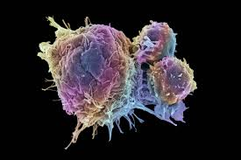

Figure 2 Cancer cell Vs Normal cell [4]

Ignore signals that warn cells to cease dividing or die in the regular course of things, this process known as programmed cell death or apoptosis.

Expand to other parts of the body by invading neighboring areas. When normal cells come to contact with other cell they cease growing and most normal cells do not travel around the body.

Instruct blood vessels to expand in the direction of malignancies. This blood veins provide oxygen and nourishment to tumors while also removing waste items.

Hide from the immune system. The immune system normaly eliminates damaged or abnormal cells.

## 2.2 Types of gene that causes cancer

The genetic changes that contribute to cancer tend to affect three main types of genes proto-oncogenes; tumor suppressors gene and DNA repair genes. These changes referred to as cancers drivers. [5]

P53, also known as TP53, is the most commonly mutated gene in cancer patients. A missing or damaged p53 gene is seen in more than half of all malignancies. The majority of mutations in the p53 gene are acquired. Although p53 mutations in the germ line are uncommon, those who have them are at a higher risk of developing a variety of cancers.

Most commonly mutated gene in people with cancer is P53 or TP53. More than 50% of cancers involve missing or damaged P53 gene mutations are aquaired. Germline P53 mutations are rare, but patients who carry them are at ahigher risk of development.[6]

Proto-oncogenes; play role in normal cell division and proliferation. When certain genes are mutated in specific ways or become more active than usual, they can turn into cancer causing genes.

Tumor suppressor genes are also engaging in cell division and growth control. Certain mutations in tumor suppresser gene can cause cells to divide uncontrollably.

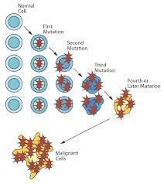

Figure 3 how genes cause cancer [7]

DNA repair genes are responsible for repairing damaged DNA. Cells with mutations in theses gene are more likely to generate mutations in other genes and chromosomal alterations.

# 2.3 Cancer diagnosis

A computer tomography (CT) scan, bone scan magnetic resonance imaging (IMR), positron emission tomography (PET) scan, ultrasound and X-ray are some of the imaging techniques used to diagnose cancer. During a biopsy your doctor takes a sample of cells foe laboratory testing.

An expert who examines cell or tissue samples under a microscope almost invariable diagnosis cancer. In some circumstance, tests on proteins, DNA and RNA of cell can help the doctor determining whether or not there is cancer. When deciding on the best treatment options, these test findings are crucial.

# 3 Types of cancer treatment

**Biomarker testing for cancer treatment;**biomarker testing is a method of looking for cancer related genes, proteins, and other chemicals (also known as biomarker or tumor markers).

**Chemotherapy;** is a cancer treatment in which chemicals are used to kill cancer cells.

**Hormone therapy;**is a treatment that slows or stop the growth of cancer that utilize hormones to proliferate, such as breast and prostate cancer.

**Immunotherapy to treat cancer;**is a cancer treatment that boosts our immune system’s ability to fight cancer.

**Radiation therapy;**is cancer treatment that involves administrating high doses of radiation to cancer cells in order to kill them and shrink tumors.

**Stem cell translation;** are operation that restore blood-forming stem cells in cancer patients whose stem cell have been damaged by extremely high doses of chemotherapy or radiation.

**Surgery;** is procedure in which a surgeon removes cancer from the body to cancer.

**Targeted therapy;** is cancer treatment that focuses on the modification that help cancer cell grow, divided and spread. [8]

# 4 Monoclonal antibody for cancer treatment

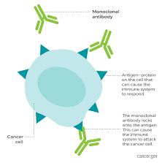

Figure 4 Monoclonal Antibodies in cancer treatment [9]

Antibodies are proteins produce naturally by the body assist the immune system in recognizing and destroying disease causing organism such as bacteria and viruses. Monoclonal antibodies like own antibodies, recognize specific targets.

Along with surgery, radiation, and chemotherapy, monoclonal antibody-based immunotherapy is increasingly considered a key component of cancer treatment. Monoclonal antibodies have a number of clinically useful modes of action.

Antibodies can target tumor cells directly while also encouraging the development of long-lasting anti-tumor response.

These monoclonal antibodies are used to treat cancer in variety of ways. There are form cancers of targeted cancer therapy, which means they are made to wore with certain cancer cells.

In 1983 a patient with non-lymphoma Hodgkin’s was treated with the first monoclonal antibodies used for cancer treatment. Back then even strong main efficacy finding wasn’t enough to overcome all of the therapy’s drawback and limitations. However the field has quickly progressed since in.

Antibodies can also target tumor cells directly while also encouraging the generation of long-lasting anti-tumor immune responses. Antibodies multiple qualities as a therapeutic platform have led to the development of new cancer therapy techniques with significant implications for cancer care.

### 4.1 Immunotherapy with monoclonal antibodies

Some monoclonal antibodies are also immunotherapy because they help turn the immune therapy. For example some monoclonal antibodies mark cancer cells so that the immune system will better recognize and destroy them. And other monoclonal antibodies bring T cells close to cancer cells, helping the immune cells kill the cancer cells. This procedure allows T lymphocytes to approach the leukemia cells near enough to respond to and kill them.

Along with surgery, radiation, and chemotherapy, is now considered a key component of cancer treatment. Monoclonal antibodies have a number of clinically useful modes of action. Antibodies can also target tumor cells directly.

Monoclonal antibodies can have a variety of adverse effects that vary from person to person. The ones you get and how they make you feel are determined by a variety of factors, how healthy you were prior to treatment , your cancer kind ,how advanced it is, the type of monoclonal antibodies you are getting, and the amount.

Monoclonal antibody medicines are cancer treatments that use the body’s own immune system to combat the disease. These medications may be used in conjunction with other cancer therapies.

Whenmonoclonalantibodies are coupled to a tiny radioactive particle, it transports the treatment directly to cancer cells, perhaps reducing the amount of radiation that reaches healthy cells. Radio immunotherapy is a type of cancer treatment that differs from normal radiation therapy.

### 4.2 Monoclonal antibody drugs for cancer

Monoclonal antibodies are made to work in a variety of ways. Depending on the medicine, it may work in more than one way. The drug role in assisting the immune system could include the following

**Detection of cancer cell;** antibodies are used by some immune system cells to locate the attacks target. Cancer cells coated in monoclonal antibodies may be easier to identify and treat. Cell membrane breakdown is triggered some monoclonal antibodies can activate an immune response that destroys a cancer cells outer wall membrane.

**Stop cell growth;** some monoclonal antibodies prevent cancer cells from interacting with proteins that promote cell proliferation, which is important for tumor growth and survival.

**Preventing blood vessel growth;**A blood supply is required for malignant tumor to grow and survive. Some monoclonal antibody medications interfere with protein cell interaction, which are required for the formation of new blood vessels.

Immune system inhibitors are blocked certain proteins that bind to immune system cells operate as regulators, preventing the system from becoming overactive. Monoclonal antibodies are antibodies that attach a specific protein.

**Directly attacking cancer cells;**Even though they were created for a different function, some monoclonal antibodies may target the cell more directly. When some of these antibodies bind to a cell, a cascade of events within the cell may drive the cell to self-destruct.

**Delivering radiation treatment;**the capacity of monoclonal antibody to bind with a cancer cell allows it to be engineering.

Because of the ability of a monoclonal antibody to attach to a cancer cell, it can be used as a delivery vehicle for other treatments. When a monoclonal antibody is coupled to tiny radioactive particle, it transports the treatment directly to cancer cells, perhaps reducing the amount of radiation that reaches healthy cells. The deviation from the norm

**Delivering chemotherapy;**similar to monoclonal antibodies some chemotherapeutic drugs are coupled to monoclonal antibodies in order to deliver the treatment directly to the cancer cell while avoiding healthy cells. [10]

# 5 Gene therapy used in cancer treatment

Gene therapy over the years, the main focus of gene therapy research has been to treat cancer.

Although no cancer gene therapy drugs are currently on the market, significant progress has recently been achieved in characterizing possible targets and creating viral and non-viral gene delivery.

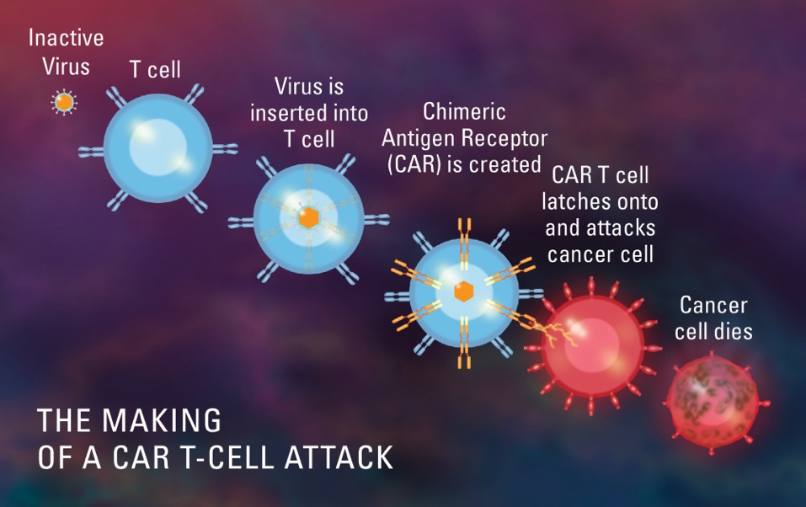

Figure 5 Gene therapy for cancer treatment [11]

Gene therapy entails transferring genetic material to specific cells or tissues and expressing it in order to achieve therapeutic impact.

Cancer gene therapy is the transfer of nucleic acids into tumor or normal cells to eliminate or reduce tumor burden by direct cell killing, immune modulation, or correcting genetic errors to reverse the malignant state.

DNA can be introduced to target cells for example vivo DNA can be injected into cells and then reintroduced to the host or DNA can be introduced directly into target cells in vivo. Vectors are agents that aid in the transmission of genes to recipient cells.

Viruses include replication-detective virus, leptosomes, and a delivery complex consisting of nucleic acid coupled to legends. Viruses deliver genes to cells.

Cancer gene therapy has been researched using retroviruses, adenoviruses, and herpes virus as a vector. Retroviruses are single-stranded RNA viruses with structural genes and 5 and 3 long-terminal repeat sequences.

Foreign genes, often known as transgene can be inserted into a retrovirus that has had one or more structural genes removed. When a recombinant virus infects a cell, it integrates into the host genome and expresses both viral and transgenic genes. Retroviral vectors that are defective cannot be replicated again. The genetic construction of this vector is not complicated, which is an advantage. Retrovirus also generates a weak immunological response from their hosts. The lake of target cells specifically and incorporation into only active dividing cells are both disadvantage.

Distinct vectors have different qualities in terms of transduction efficiency and efficacy in expressing genes that have been inserted. Furthermore they differ in expression as well as their safety profile.

Depending on the requirement, different vectors can be used for different.

Virus vectors are currently through to be the most effective gene delivery technology for in vivo gene transfer. The gene transfer vector should be in theory, be able to target a specific tissue with high transduction efficiency and maintain steady, regulated gene expression without causing any side effects or immunogenic responses.

**Several gene therapy techniques** have been developed, including suicide gene therapy, oncolytic viral treatment, antagonisms and gene therapy vaccines.

### 5.1 Viral vectors

Adenovirus, lentinovirus andretrovirus (including the human immunodeficiency)

Gene transfer is a revolutionary therapy method that involves inserting new genes in to a malignant cell or surrounding tissue in order to cause cell death or delay cancer growth. This therapeutic method is exceeding adaptable and clinical trials have used a wide range of genes and vectors with positive result.

Viral vectors have been employed for the treatment of various diseases such as metabolic, cardiovascular, muscular, hematologic, ophthalmologic, and infectious diseases and different types of cancer. Recent development in the area of immunotherapy has provided both preventive and therapeutic approaches.[12]

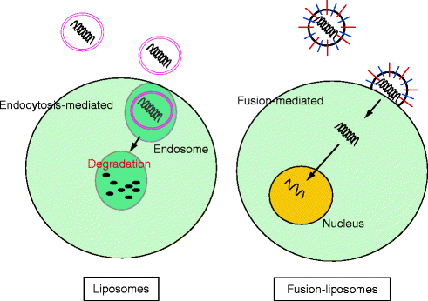

Figure 6 Non-viral Vector for cancer therapy [13]

### 5.6 Immunotherapy

Immune gene therapy; several genes used for cytokines reduce tumorigenicity and enhance systemic immunity to tumors.

For more than a century, cancer treatment has aimed to increase the immune system’s ability to target and eliminate cancer cells. Traditional immunotherapy, on the other hand, has had mixed results, as cancer cells have involved strategies to avoid immune detection.

Gene therapy is current being employed to develop recombinant cancer vaccines. Unlike vaccinations against infectious agents, these vaccines are designed to cure or contain disease by teaching the patient’s immune system to recognize cancer cells by exposing it to highly antigenic and immune stimulatory cellular debris.

## Gene transfer

Gene transfer or insertion is one of the most interesting treatments to arise from the concept of gene therapy. This is brand new therapy approach that involves inserting a foreign gene into the cancer cell or surrounding tissue. Suicide genes (genes that trigger cellular death when activated) and other gene with a variety of roles have been proposed for this form of therapy.

The field of cancer gene therapy is quickly expanding and it will undoubtedly be a part of cancer therapies in the future. Thanks to the development of genetic engineering some extremely interesting in cancer vaccine treatments are in late stage trials. Furthermore gene transfer technology for cancer treatment has a lot of promises in terms of improving the efficiency of current chemotherapeutic treatment regimens.[14]

Cell therapy**;the oldest biological against cancer**

Cell therapy as opposed to tiny molecules or antibodies is described as the use of a whole cell as drug. There are now only a few verified indications worldwide, and they differ widely from country. Hematopoietic stem cells, on the other hand have been employed in the recent decade (undifferentiated stem cells from bone marrow).taking healthy stem cells from bone marrow foe alteration is routine approach for treating blood cancer. The immune system is subsequently bombard with chemo, which kills both malignant and healthy cells following that bone marrow stem cells are implanted into the patient in an attempt to restore the system. A standard procedure to treat blood cancer consists in talking healthy blood steam cells from bone marrow first for modification. Once this is done, the steam cells from bone marrow samples are grafted into the patient to try and replenish the system. [15]

Role of cytokines in cancer

In cancer pathogenesis the mixture of cytokines produced in the tumor microenvironment plays key role in cancer progression. Cytokines, which are secreted in response to infection, inflammation, and immunology, have been shown to slow the advancement of cancer, alternatively cancer cells can respond to cytokines produced by the host, which boost proliferation, suppress apoptosis, and aid invasion and met stability and also they can stop tumors from growing and progressing.

Cytokines are important regulators of both innate and adaptive immunity, allowing immune cells to interact over short distances.

Cytokines are produced in response to a wide variety of cellular stressors such as carcinogen-induced damage, infection and response in certain situation, with the goal of managing cellular stress and reducing cellular damage.

# 6 Nanotechnology for cancer diagnosis and treatment

**Nanotechnology** is area of science and engineering in which phenomena occurring at nanometer dimensions are used in the design, characterization, manufacture, and application of materials, structures, devices, and system. [16]

Nanotechnology has a very high potential in the diagnosis, treatment, and management of cancer.

## Nanotechnology in diagnosis of cancer

Nanotechnology has the potential to detect cancer related chemicals quickly and sensitively, allowing scientists to discover molecular alternations in a small percentage of cells. Nanotechnology has the ability to create completely new and very effective medicinal treatments.

Nanotechnology can detect changes in a very tiny number of cells due to its microscopic size. It can distinguish between normal and cancerous cells. It can also reach cancer in its early stages, when cells have only just begun to divide and the disease is easier to treat.

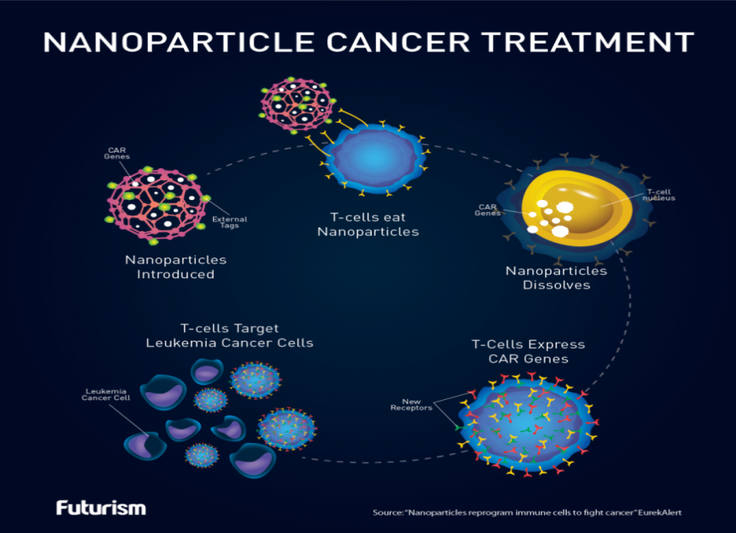

Figure 7 Nanotechnology for cancer treatment [17]

Surgery, radiation and chemotherapy are the cancer treatments available right now. All three procedures carry the danger of causing damage to healthy tissue or resulting in inadequate cancer elimination. Nanotechnology has the potential to direct and selective target chemotherapies to malignant cells and neoplasm, guide tumor surgical excision, and improve the therapeutic efficacy of radiation based and other existing treatments.

All of these can lead to lower risk for the patient and a higher chance of survival.

Nanotechnology cancer therapy research extends beyond medication delivery to the development of novel medicines based only on nonmaterial characteristics.

Nanoparticles are large enough to encapsulate a large number of small molecules of various sorts. At the same time, legends like as tiny molecules, DNA or RNA strands, peptides, aptamers, or antibodies can be functionalized on the nanoparticles comparatively large surface area. This legend can be utilized for medicinal purposes or to drive nanoparticles in specific directions.

The characteristics properties of nanoparticles (NPs) like small size, customized surface, improved solubility, multi-functionally, and administration through different routines are utmost importance [18]

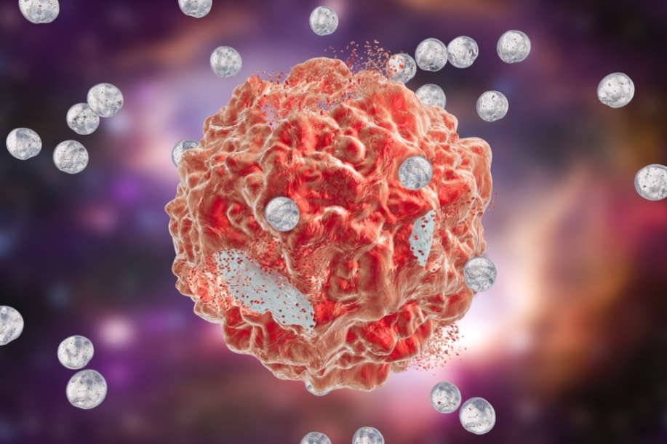

Figure 8 Nano particles [19]

These characteristics permit combination medication administration, multi-modality treatment, and theragnostic (therapeutic and diagnostic) action. Nanoparticles physical features, like as energy absorption and re-radiation, can be exploited to damage sick tissue in applications like laser ablation and hyperthermia.

Immune depots put in or near tumors for in situ vaccination and artificial antigen presenting cells are two more applications of nanotechnology in immunotherapy. As our understanding of cancer immunotherapy improves these and other techniques advance and perfected.

**6.1 Radiation therapy** is a given to almost half of all cancer patients at some point throughout their treatment. High energy radiation is used in radiation therapy to shrink tumors and kill cancer cells. Radiation therapy destroys cancer cells by causing cellular death by destroying their DNA.

Radiation therapy can either directly damage DNA or create changed particles (atoms with an odd or unpaired number of electrons) within the cells, which can damage DNA, X-ray, gamma ray and charged particles are employed in the majority of cancer treatments. As a result there are toxic to all cells, not just cancer cells, and are administrated in amounts that are as effective as possible. [20]

**Nanotechnology used in cancer biomarker screening;**biomarkers for cancer are biological characteristics whose presence or absences signals the presence or status of tumor. These markers are used to research cellular process and to monitor or identify changes in cancer cells, and the findings could lead to a better understanding of cancers in future.

Proteins, protein fragments, and DNA can all be used as biomarker. Tumor biomarker, which are signs of a tumor are one of them that may be evaluated to confirm the presence of specific cancers.

### Tools of nanotechnology for cancer therapy

The use of small molecular structures and particles as method for delivering medications has fueled the development of nanotechnology. Leptosomes, micelles, dendrite macromolecules, quantum dots and carbon nanotubes are examples of nano-carries that have been employed in cancer treatment.

**Liposomes are** one of the most common types of nanoparticles.

To help diagnose cancer, doctors now frequently prescribe imaging tests such as X-rays, CT-scans, and MRIs. However this test can only detect the disease once it has grown large enough to be seen. The cancer may have multiplied and spread to other places of the body by that time. These scans can’t tell if tumor is cancerous or not.

Nanotechnology can detect changes in very tiny number of cells due to its microscopic size. It can distinguish between normal and cancerous cells. It can also reach cancer in its early stages, when cells have only just begun to divide and the disease is easier to treat.

Nanotechnology has the potential to make malignancies more visible on imaging tests. Nanoparticles that have been coated with antibodies or other chemicals are more likely to identify and attach to cancer cells. Particles can be coated with chemicals that emit a signal when they come across cancer.

## Nanotechnology in treating cancer

Nanotechnology has the potential to make cancer therapies more accurate and safer.

Nanotechnology with special designees delivers drugs like chemotherapy directly to tumors. They don’t give the drug out until they get there; this prevents the medications from harming healthy tissues in the tumors vicinity. Side effects are caused by injury.

Nanoparticles small size allows them to deliver medicines to parts of the body that would otherwise be difficult to reach.

**Passive tumor accumulation;** an efficient cancer drug delivery should achieve high accumulation in tumor and spare the surrounding healthy tissue.

**Active tumor accumulation;** EPR effect, which serves as nanoparticles passive tumor targeting scheme is responsible for accumulation of particle in tumor region.

# Conclusion

Researchers use gene transfer to transfer a gene from one person to another. A foreign gene into cancer cells directly or infiltrating the tissue around it the objective is to the newly implanted gene will result in the cancer cells to perish or cancer cells to be prevented and the tissue around it from being funneled blood to tumors, depriving them of oxygen and nutrients.

Gene therapy has promised in the treatment of cancer, cystic fibrosis, heart disease, diabetes and so on. For cancer various gene therapy strategies have been used including pro-drug activating suicide gene therapy, oncolytic, antigenic gene therapy and so on.

Monoclonal antibodies can be utilized on their own or to deliver medications, radioactive materials, and poisonous compounds to cancer cells. Monoclonal antibodies utilized as medications, help the body natural immune system fight cancer. And also they look for specific proteins on cancer cells that are associated to the proliferation of those cells.

# References

[1] *Cancer*. (2021, March 3). WHO. <https://www.who.int/news-room/fact-sheets/detail/cancer>

[2] Scince Nordic. (2019, February 19). *Cancer Cells* [Illustration]. Cancer Cell. https://sciencenordic.com/cancer-denmark-forskerzonen/are-all-cancer-cells-the-same/1553415

[3] National Cancer Institute. (2021, May 5). *What Is Cancer?* Cancer.Gov. <https://www.cancer.gov/about-cancer/understanding/what-is-cancer#:~:text=The%20Definition%20of%20Cancer,-Cancer%20is%20a&text=When%20cells%20grow%20old%20or,which%20are%20lumps%20of%20tissue>.

[4] Very Well Health. (2019, December 7). *Cancer cell Vs Norma Cells* [Illustration]. Cancer Cell Vs Normal Cells. https://www.verywellhealth.com/cancer-cells-vs-normal-cells-2248794

[5] National Cancer Institute. (2016, June 3). *“Drivers” of Cancer*. Drives of Cancer. <https://ruesch.georgetown.edu/whatiscancer/#:~:text=%E2%80%9CDrivers%E2%80%9D%20of%20Cancer&text=drivers%E2%80%9D%20of%20cancer.-,The%20genetic%20changes%20that%20contribute%20to%20cancer%20tend%20to%20affect,normal%20cell%20growth%20and%20division>.

[6] Cancer.Net Editorial Board,. (2018). *The Genetics of Cancer | Cancer.Net*. The Genetics of Cancer. <https://www.google.com/search?q=Most+commonly+mutated+gene+in+people+with+cancer+is+P53+or+TP53.+More+than+50%25+of+cancers+involve+missing+or+damaged+P53+gene+mutations+are+aquaired.+Germline+P53+mutations+are+rare%2C+but+patients+who+carry+them+are+at+ahigher+risk+of+development.&rlz=1C5CHFA_enET933ET933&oq=Most+commonly+mutated+gene+in+people+with+cancer+is+P53+or+TP53.+More+than+50%25+of+cancers+involve+missing+or+damaged+P53+gene+mutations+are+aquaired.+Germline+P53+mutations+are+rare%2C+but+patients+who+carry+them+are+at+ahigher+risk+of+development.&aqs=chrome..69i57.11454j0j4&sourceid=chrome&ie=UTF-8>

[7] ENT Health Library HomeConditions Health Centers Drugs, Herbs & Supplements. (2020, March 7). *How Genes Cause Cancer* [Diagram]. How Genes Cause Cancer. https://www.spectrumhealthlakeland.org/lakeland-ear-nose-and-throat/ent-health-library/Content/85/p07205/

[8] National Cancer Institute. (2019). *Types of Cancer Treatment*. <https://www.cancer.gov/about-cancer/treatment/types>

[9] (2019, August 24). *Monoclonal Antibodies cancer cell showing a monoclonal antibody locking onto an antigen on the cell’s surfaceENLARGE Some monoclonal antibodies mark cancer cells so that the immune system will better recognize and destroy them. Credit: National Cancer Institute* [Diagram]. Some Monoclonal Antibodies Mark Cancer Cells so That the Immune System Will Better Recognize and Destroy Them. https://www.cancer.gov/about-cancer/treatment/types/immunotherapy/monoclonal-antibodies

[10] Newsletter: Mayo Clinic Health Letter — Digital Edition. (2019, August 20). *Monoclonal antibody drugs for cancer: How they work*. Mayo Clinic. <https://www.mayoclinic.org/diseases-conditions/cancer/in-depth/monoclonal-antibody/art-20047808>

[11] David A. Williams, MD. (2019, June 12). *How is Gene Therapy Being Used to Treat Cancer?* [Diagram]. How Is Gene Therapy Being Used to Treat Cancer? https://blog.dana-farber.org/insight/2018/04/gene-therapy-used-treat-cancer/

[12] PMC. (2018, May 21). *Viral Vectors in Gene Therapy*. Viral Vectors in Gene Therapy. <https://www.ncbi.nlm.nih.gov/pmc/articles/PMC6023384/>

[13] Authors and affiliations. (2017, March 10). *Non-Viral Vector for Cancer Therapy* [Illusion]. Non-Viral Vector for Cancer Therapy. https://link.springer.com/referenceworkentry/10.1007%2F978-3-642-16483-5_4121

[14] Deanna Cross, PhD and James K. Burmester, PhD. (2006, August). *Gene transfer*. Gene Transfer. <https://www.ncbi.nlm.nih.gov/pmc/articles/PMC1570487/>

[15] Cancer.Net Editorial Board. (2020, February). *What is a Bone Marrow Transplant (Stem Cell Transplant)?* <https://www.cancer.net/navigating-cancer-care/how-cancer-treated/bone-marrowstem-cell-transplantation/what-bone-marrow-transplant-stem-cell-transplant>

[16] The SCENIHR opinion states: (2006). *Nanotechnologies*. Source & ©: SCENIHR The Appropriateness of Existing Methodologies to Assess the Potential Risks Associated with Engineered and Adventitious Products of Nanotechnologies (2006),. <https://ec.europa.eu/health/scientific_committees/opinions_layman/en/nanotechnologies/l-3/1-introduction.htm>

[17] Catalina Rose. (2019, August 13). *Can Nanotechnology Win The Race For Cancer Medication?* [Illustration]. Can Nanotechnology Win The Race For Cancer Medication? https://nuclineers.com/nanotechnology-cancer-medication/

[18] Awasthi, Rajendra; Roseblade, Ariane; Hansbro, Philip M.; Rathbone, Michael John; Dua, Kamal; Bebawy, Mary. (2018, November 14). *Nanoparticles in Cancer Treatment*.

[19] By Laura Panjwani. (2018, February 28). *Nanoparticle-Based Cancer Treatment* [Illustration]. Nanoparticle-Based Cancer Treatment. <https://www.drugdiscoverytrends.com/nanoparticle-based-cancer-treatment-a-look-at-its-origins-and-whats-next/>

[20] National Cancer Institute. (2019b, January 8). *Radiation Therapy to Treat Cancer*. National Institutes of Health. https://www.cancer.gov/about-cancer/treatment/types/radiation-therapy

Bentham Science Publishers. <https://www.ingentaconnect.com/content/ben/cdt/2018/00000019/00000014/art00009>

Cancan Jin,1 Kankai Wang,2 Anthony Oppong-Gyebi,3 and Jiangnan Hu3,✉. (2020). *Application of Nanotechnology in Cancer Diagnosis and Therapy*. Int J Med Sci. https://www.ncbi.nlm.nih.gov/pmc/articles/PMC7646098/

Bio-Research Laboratory, Rajendra Mishra School of Engineering Entrepreneurship Indian Institute of Technology Kharagpur, Kharagpur, India. (2020). *Nanotechnology in Drug Delivery System*. P Prabhakar et al /J. Pharm. Sci. & Res. https://www.researchgate.net/profile/Pawan-Prabhakar/publication/341591438_Nanotechnology_in_Drug_Delivery_System_Challenges_and_Opportunities/links/5fc3aecd92851c933f72d7e1/Nanotechnology-in-Drug-Delivery-System-Challenges-and-Opportunities.pdf

*Depending on the requirement, different vectors can be used for different.* (2006, August). Depending on the Requirement, Different Vectors Can Be Used for Different. <https://www.ncbi.nlm.nih.gov/pmc/articles/PMC1570487/>

Int J Med sci. 2020; 17(18): 2964-2973.

Bray F, Ferly J, soerjomataram I, siegel RL, Torre LA, jemal A. Global cancer statestics 2018: GLOBOCAN estimates of incidence and mortality worledwide for 36 cancers in 185 countries. CA Cancer J Clin. 2018; 68:394-424.

Shi H, Sun M, Liu L, Wang Z. Chimeric antigen receptor for adoptive immunotherapy of cancer: latest research and future prospects. Mol Cancer 2014;13:219.

Scott AM, Wolchok JD, old LJ. Antibody therapy of cancer. Net rev cancer 2012; 12:278-87.